About you | [Salutation] | Natalie | [Middle name] | Seiz
About you | [Enter your biography]
About you | [Enter the institution with which you are affiliated]

Your article
Wu Hao
[Enter any variant forms of your headword – OPTIONAL]
Wu Hao resides in Taiwan and is known for his oil paintings and woodblock prints, which are strongly influenced by Chinese traditional folk motifs.
Wu Hao resides in Taiwan and is known for his oil paintings and woodblock prints, which are strongly influenced by Chinese traditional folk motifs. Having the opportunity to learn painting and drawing techniques in his spare time, he studied under the well-known artist and teacher Li Chung-sheng (1912-1984 李仲生). Wu was one of the founders of the Ton Fan Art Group (Dongfang huahui, Eastern painting group東方畫會). Later, he developed an interest in the print medium, and in 1966 became a member of the Modern Graphics Association (Xiandai ban huahui 現代版畫會). By the 1980s his work became more decorative, particularly in his use of bold colours and stylized subjects drawn in dark outlines, resulting in bright and eye-catching works. Wu Hao was inspired by Chinese folk art traditions at a time when many of his contemporaries, who had left to study abroad, were interested in modernist academic trends and the use of Eastern aesthetics in genres such as Abstract Expressionism. Wu’s work was known in Taiwan not only for its “Chineseness” but also for its nativist sentiments (xiangtu鄉土) which alluded to the nostalgia prevalent in Taiwan in the 1970s.

Born in Nanjing from a middle-class family, Wu came to Taiwan in 1949 when the Nationalist government was leaving China at the time of Communist insurgency. Despite his desire to paint when he was younger (influenced by his grandfather who did traditional Chinese painting) he could not elicit his father’s support, who felt he needed a more viable profession. The year after he arrived in Taiwan, he joined the air force, where he served as an officer until 1971. His arrival in Taiwan enabled him to pursue art studies, learn Western drawing and painting techniques, work with various materials, and gave him the opportunity to meet and work with a number of teachers and fellow artists.

In 1950-51 he studied painting under Li Chung-sheng and also started painting with artists such as Hsia Yang (夏陽; 1932 –) who was one of the founders of the Ton Fan Group (東方畫會). In 1952 Wu, along with other Ton Fan artists Hsia and Ouyang Wen-yuan (歐陽文苑), converted an air-raid shelter into an art studio that was also used as a meeting and exhibition space for other artists. In 1964, Wu became interested in woodcut prints, as paint was proving to be expensive and prints were easier to sell. The print medium enabled him to express a modern art which also had a Chinese sensibility, something he aspired to reflect in his works. He was further influenced by elements such as the Dunhuang cave paintings, and worked to depict a wide range of subjects including aspects of everyday life in Taiwan, plants, fruit, landscapes, people and animals.

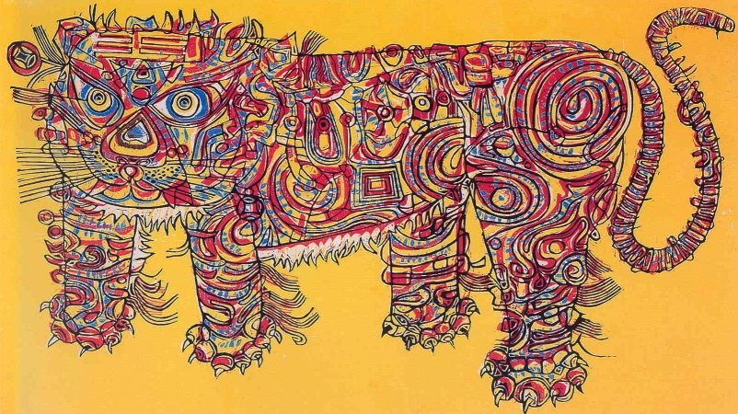
Wu Hao
Holiday Tiger 1964
woodcut; 46 x 81cm,
Collection of the National Taiwan Museum of Fine Arts

Further reading:
---- The Momentum of the Group Ton-fan Marked in Shanghai (Dongfang huahui jinianzhan shanghai meishuguan zhanlan zhuanji) (1999), National Taiwan Museum of Fine Arts,Taichung.

HSIAO Chong-ray (Xiao Qiong-rui蕭瓊瑞)( 2007), The Colour of Ilha Formosa: A History of Taiwanese Art (Daoyu secai: taiwan meishu shilun), The Grand East Book Co., Ltd ,Taipei,.

